**Load Testing for 1000 HTTP requests**

I used Apache JMeter benchmarking tool to perform load testing on the virtual machine and used an extension called Container Watch for docket. My findings are as follows:

**Docker:**

As the graph shows, CPU utilization bumps up-to more than 60% when the request simulation is carried out. After the simulation is complete, it comes down in the range of 18% - 25%.

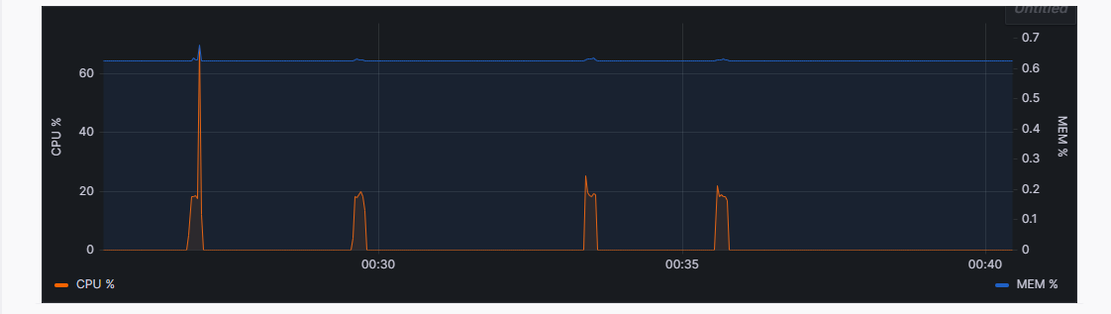

**JMeter:**

The following table shows 1000 simulated requests with the timestamp, size of the data sent, request latency, etc.

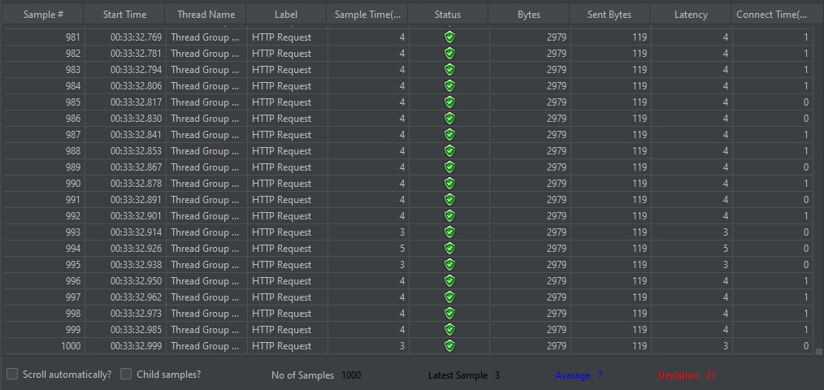

This table shows the summary of the above 1000 HTTP requests. Some of the important metrics are:

**Error %:** 0

**Throughput:** 14.1/sec



I carried out the simulation twice. The following graph shows the data of 2000 samples. Some of the important metrics are:

**Throughput:** 847.021/min)

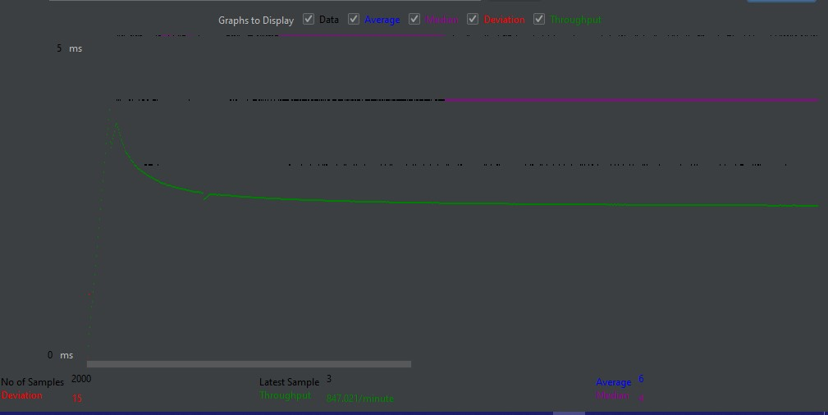

**Conclusion:**

In conclusion, our comparison of Docker and Vagrant deployments for a web app highlights Docker's faster startup time as a significant advantage. However, Vagrant is more resource-efficient and offers precise environment control. The choice depends on project needs, favoring Docker for speed and scalability and Vagrant for resource-conscious scenarios.